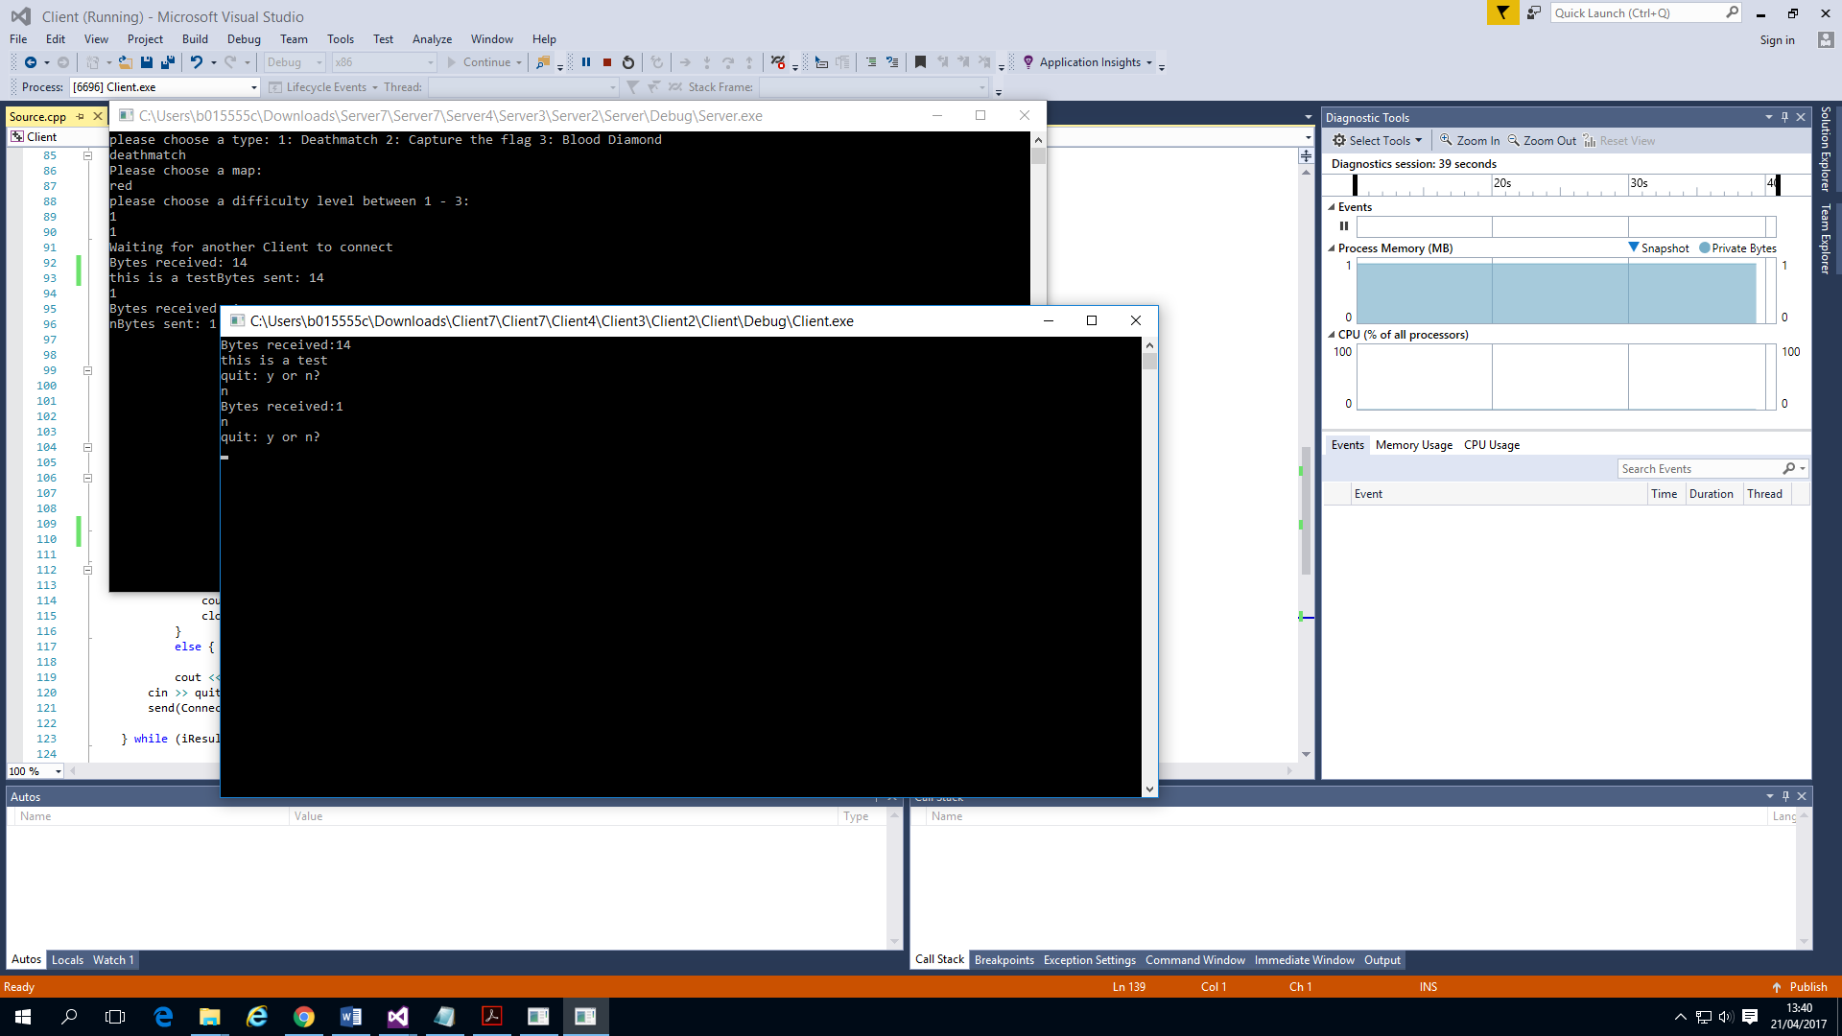This is a screenshot of the configuration of the server. When a client joins the server it creates a thread, then passes the game information to the client and prints out that it is waiting for another client to join and won’t join the game until there is two or more clients joined.

This screenshot shows than two clients join the server the game starts and puts the players into the

game and adds them to the queue.

If there is above the maximum allowed clients the game is allowed then the client is put into the spectator queue, and only allowed to join when there is a space in the game aka when a client leaves the game.

Also when the client is allowed into the game it shows the transition between the spectator queue and them being put into the game queue by printing out the lines “Leaving spectator queue joining game”.

My log includes the IP and port of the server, which client joined the server along with their ID. It also includes the total number of clients that have joined the server.

127.0.0.1 27015Client0joined at: Fri Apr 21 13:39:43 2017

Total number of clients: 1

Client1joined at: Fri Apr 21 13:39:43 2017

Total number of clients: 2